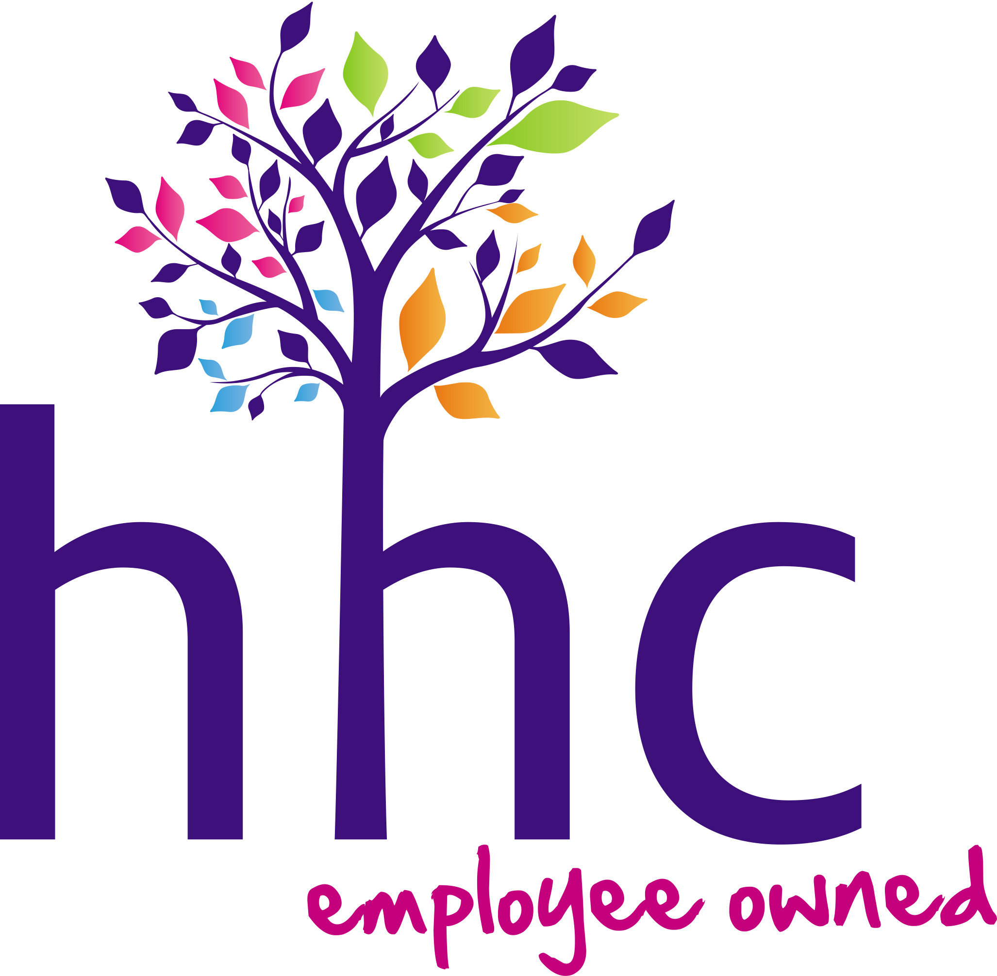

PRESS RELEASE

Mar 6, 2023

LEADING SOCIAL CARE PROVIDER CLINCHES TOP DIGITAL HEALTH AWARD WITH GROUNDBREAKING PRESSURE ULCER PREVENTION TRIAL

Highlights:
- HHC pressure ulcer prevention pilot scheme wins leading digital health and care award
- Scheme saw dramatic reduction in suffering and hospital admissions
- District Nurse call outs ‘reduced by 50%’ during trail - hailed as a game changer for care at home sector by Lead Nurse

The Highlands’ largest social care provider, Highland Home Carers (HHC), has been recognised at the 6th annual Digital Health & Care Awards for its groundbreaking work helping combat pressure ulcers in a care at home setting. At the Edinburgh ceremony - which is Scotland’s foremost celebration of digital innovation across the health and social care sector - HHC Director of Operations, Carolanne Mainland, and her team won the award in the Data Driven Innovation category.

Mainland led her Team of Practice Support Technicians in the groundbreaking Pressure Ulcer reduction and prevention pilot utilising an existing Provisio SEM scanner. The technology gives an objective risk indicator by means of a delta Score which enabled Practice Support Technicians to take action to mitigate the risk of developing a Pressure Ulcer.

Speaking about the revolutionary pilot scheme, Mainland commented:

“We set ourselves ambitious targets of reducing avoidable Pressure Ulcers in people assessed to be at high risk of developing them and reducing hospital admissions as a result of a Pressure Ulcer. We aimed to reduce unnecessary hospital admissions by 40% and to reduce overall Pressure Ulcers by 70%. But not one single person on the study developed a Pressure Ulcer meaning there were no hospital admissions whatsoever.

“The empirical data of the pilot is now drawing the attention of both Clinicians and Health Economists. For example, although a subjective measure, we estimate that the study resulted in circa 50% reduction in District Nurse callouts. Where previously, Care Practitioners would call District Nurses to look at redness on the surface of the skin, our Practice Support Technicians were enabled to introduce interventions in response to a delta score of =>0.6.”

In commending HHC for the award, the Highland Lead Nurse for Care at Home, Jamie Smith, QN, commented:

“I have been hugely impressed by the forward-thinking can-do attitude of Highland Home Carers (HHC) in embracing this exciting project to identify early changes indicative of pressure damage. This allows HHC as part of the wider multi-disciplinary team to ensure effective risk assessment and management to decrease individuals likelihood of developing pressure damage. This project has been instrumental in motivating HHC clients to look out for changes to their own pressure areas, encourage mobility and positional changes in order to “beat their own score”. This project has empowered HHC teams in advocating the needs of their clients to community nursing colleagues to ensure good outcomes.”

High cost of pressure ulcers
In 2015 the UK Government estimated the cost of treating each Pressure Ulcer, depending on the grade, as between £1,214- £14,108. Some people’s skin may deteriorate more quickly at home than in a healthcare setting for a variety of reasons, including: poor nutrition/hydration; continence issues; poor mobility; inability to complete tasks themselves/reliance on a family member or social care practitioner for regular visits to tend to basic needs.

Mainland and her team pioneered the use of the Provisio SEM Scanner clinical device in people’s own homes and through problem solving, developed a Standard Operating Procedure and pocket guide meaning that this work is now scalable in a Care at Home setting.

No-one in the study developed a Pressure Ulcer, which prevented avoidable human pain, suffering and indignity as well as related costs of Pressure Ulcer treatment. Further, the study upskilled the Social Care Team of Practice Support Technicians and reduced unnecessary District Nurse time at the same time as maximising targeted Nursing intervention when it was required.

Due to the far reaching measurable health and financial benefits, HHC’s eye catching pilot is being hailed as a game changer for the care sector…

END

Editor’s notes:

Operating across the Highland region since 1994, Highland Home Carers care for and support people living in their own homes, people often with highly complex health and social care needs, and working alongside doctors, nurses and other health care professionals.

Alongside traditional home care, HHC provides one-to-one support work tailored to individuals’ needs. Currently providing a key service for those with complex needs in Fortrose, at Lomond & Leachkin on the New Craigs Campus, Inverness.

The care HHC provides, allows people to live well as part of their community, avoiding the need for long term hospital or residential home stays, bringing people mental and physical health benefits.

The people cared for and supported by HHC are referred by statutory partners in health or social work.

HHC has been an employee owned company since 2004, with staff owning all of the company’s shares and having a say in how the company is run through consultation and ongoing engagement, particularly in areas which directly affect the workforce. Employees are also represented at board level with three employee directors at the company nominated and elected by the wider workforce and three employee elected Trustees.

HHC implemented employee ownership as a way of addressing the issue of correctly rewarding and empowering those working in challenging roles that bring tremendous benefits to both individuals and the wider community.

HHC has a staff roster of around 250 people making it one of the largest private employers in the Highlands. It is also the biggest employee-owned company in Scotland, and one of the UK’s “top 50”.

As part of its commitment to delivering positive social change, HHC is aligned with the Community Wealth Building, National Strategy for Economic Transformation, Skills Development, Fair Work, and Developing the Young Workforce national programmes.

highland-home-carers.co.uk

For more information please contact:
Andrew Ross
t: 0797 1055 970
e: andrew@rosscreativecommunications.com

